VySkan
Product Name | 4G LTE Ultra-Long Standby Asset Tracker
Product Model | VA03-Dry
Wire-Free. Covert. Enduring.
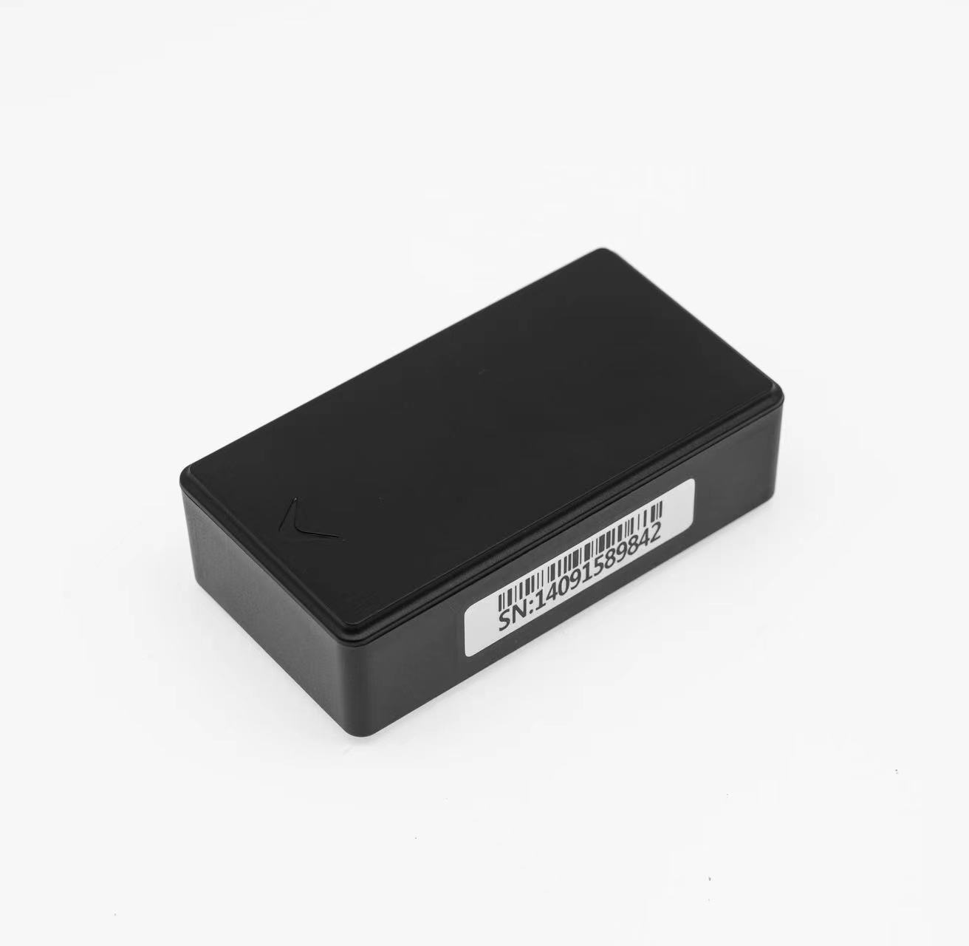
Engineered for long-term, zero-maintenance asset monitoring, the Vyskan VA03-Dry is a wire-free 4G LTE tracker that redefines endurance. Powered by a military-grade 3000mAh Li-SOCl2 battery and leveraging multi-constellation positioning including GPS, BDS, LBS, and WIFI , it delivers over 1000 days of autonomous operation. With its ultra-compact 77mm footprint and dual-tamper defense mechanisms, it is the ultimate covert "slap-and-track" solution for auto finance, high-value cargo, and discreet fleet management.

- Core Value
- 3-Year Zero-Maintenance Longevity
Equipped with a 3000mAh Li-SOCl2 battery and an extreme <20uA sleep current, it delivers up to 1095 days of tracking without recharging, drastically cutting field maintenance and battery replacement costs.
- Covert Slap-and-Track Deployment
100% wire-free with built-in NdFeB high-strength magnets, allowing for instant, zero-labor-cost installation on any metallic surface within seconds, perfectly concealed from sight.
- Dual-Sensor Tamper Defense
Features an integrated optical light sensor and a physical dismantle button that instantly trigger alerts and upload location data if maliciously removed, ensuring absolute asset security.
- Target Applications
- Auto Finance & Leasing: (Ultra-long standby and covert size ensure uncompromised vehicle tracking without draining the car's native battery).
- High-Value Cargo & Trailers: (Wire-free magnetic mounting allows rapid deployment on non-powered assets and containers).
- Anti-Theft & Covert Operations: (Dual tamper alerts and a remote smart tracking mode activate real-time emergency recovery if an asset is compromised).
- Technical Specifications
  - Cellular & GNSS
Category | Specification | Description
Network Bands | 4G LTE | Ensures robust and broad global cellular connectivity.
Positioning Mode | GPS + BDS (B1) + LBS + WIFI | Multi-layer constellation tracking for precise indoor and outdoor visibility.
Smart Tracking | Remote Activation | Transitions to continuous real-time pinging during theft or emergencies.
WIFI Module | 2.4 GHz ~ 2.5 GHz | Automatically scans and leverages local hotspots for accurate urban positioning.

  - Power & Electrical
Category | Specification | Description
Battery Capacity | 3000mAh(3V) Li-SOCl2 | High-density primary battery with <1% annual self-discharge rate.
Sleep Current | < 20μA | Industry-leading ultra-low power drain for extended 3-year lifespan.
Working Current | <35~60mA @ 3V | Highly efficient power utilization during active data transmission.
Voltage Alarm | Low Battery Alert | Proactively notifies the platform with battery percentages for fleet management.
  - Interfaces & Expandability
Category | Specification | Description
Anti-Tamper | Optical Sensor & Button | Instantly detects environmental light changes or physical detachment to trigger alarms.
Data Cache | Blind Zone Compensation | Caches trajectory data during cellular drops and uploads seamlessly upon reconnection.
Schedule Mode | Alarm & Week Modes | Customizable wake-up schedules to optimize battery life and server connections.
  - Physical & Environmental
Category | Specification | Description
Dimensions | 77mm × 41mm × 22mm | The smallest in its performance class, facilitating effortless covert concealment.
Weight | 110±3g | Extremely lightweight while housing heavy-duty industrial components.
Operating Temp. | -30℃ to 80℃ | Resilient operation in diverse and extreme climates.
Magnets | Built-in NdFeB | Extreme industrial-strength adhesion for secure metallic mounting.
- Deployment & Integration
Zero-Installation & Seamless Integration: The 100% wire-free, magnetic design eliminates complex vehicle wiring and expensive installation labor, enabling immediate fleet-wide rollout. The device supports dedicated platform directives for bulk automated configuration; pre-set commands are automatically executed the moment the device wakes up, ensuring frictionless platform integration and maximum operational efficiency.
- A personalized service prepared for you
- 1× VA03-Dry Sample Device (Pre-configured)
- Full API & Protocol Documentation
- 1-on-1 Technical Support from our Field Engineers
- Contact us
Website: https://vyskan.com/
Email: marketing@vyskan.com

